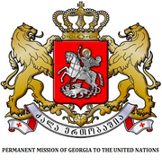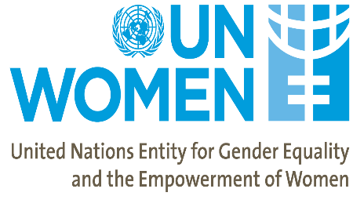

Presentation of
Fairy tale collection “Once There Was a Girl”
04:45pm - 06:00pm
ECOSOC Chamber, UNHQ
New York, 11 March 2019

The Permanent Missions of Georgia and Sweden to the United Nations, in partnership with the United Nations Entity for Gender Equality and the Empowerment of Women (UN Women) are organizing a side-event to present the fairy tale collection “Once There Was a Girl” on 11 March 2019. The side-event will be held on the side-lines of the 63rd session of the Commission on the Status of Women (CSW).

The fairy tale collection, was originally published in June 2018 as part of the UN Joint Programme for Gender Equality in Georgia, funded by the Government of Sweden.

Fairy tales can have an enormous influence over the formation of a child’s value system. They serve as an important introduction to the outside world, teaching children how to distinguish kindness from malice, recognize justice from injustice, generate empathy and encourage bravery.

UN Women Georgia decided to use the potential of fairy tales as a powerful tool in promoting Sustainable Development Goal 5 on Gender Equality, this time targeting children, the country’s future human capital. Authored by twelve Georgian writers, the wonderfully illustrated collection of 21 fairy tales “Once There Was a Girl” features female protagonists throughout, something that up until now, was in short supply among children’s literature, including fiction and school textbooks in Georgia. The collection celebrates some of the accomplishments and contributions made by Georgian women to the development of the country, or specific fields of arts, science or other courageous endeavors. In doing so, the book deftly helps to address gender inequality, which is one of the biggest hurdles the country is facing. The fairy tales recounting the courageous deeds, determination, wisdom, dignity and fight for justice of female heroines are intended to inspire girls to succeed in untraditional roles by portraying real and fictional role models close to the Georgian readers’ culture. Unpacking Georgian culture for a feminist inspiration bears special importance to counter a popular discourse in Georgia that gender equality is a foreign concept to the Georgian ethos and is imposed from the western world. In addition, the book is intended to popularize female protagonists from the national history, folklore and literature to inspire writers, artists, scholars and public at large to take a deeper look into their achievements and lives. The book is aimed at children aged 7-15 years, nurturing equality of women and men, girls and boys from an early age.

During the event, an exhibition portraying the real or fictional lives of the protagonists of the book featuring materials from Georgian archives, literature and other sources will be presented.

Draft Programme

04:45PM – 04:50PM Moderator
- H.E. Mr. Kaha Imnadze, Ambassador Extraordinary and Plenipotentiary, Permanent Representative of Georgia to the United Nations

04:50PM – 05:30PM Opening Remarks
- H.E. Ms. María Fernanda Espinosa Garcés, President of the 73rd session of the UN General Assembly (TBC)
- Representative from Georgia (TBD)
- Representative from Sweden (TBD)
- Representative from UN Women (TBD)

05:30PM – 05:40PM Speakers
- Ms. Erika Kvapilova, UN Women Representative in Georgia
- Author of the fairy tale (TBD)

05:40PM – 06:00PM Reading extracts from fairy tales

06:00PM – 06:15PM Closing Remarks

